**(ITEMS AND PRODCUTS DATABASE)**

**By**

**Sachin Gunjal**

1. **Create two Databases Name :- Brands , and Products**

CREATE DATABASE Brands

CREATE DATABASE Products

1. **Create two tables in SQL Server name as ITEMS_TABLE in Brands database and PRODUCT_TABLE in Products database.**

USE Brands

CREATE TABLE Items_Table(

Item_ID INT PRIMARY KEY,

Item_Description VARCHAR(100) NOT NULL,

Vendor_nos INT,

Vendor_Name VARCHAR(100),

Bottle_Size INT,

Bottle_Price FLOAT

----------------------------------------------------------------------

USE Products

CREATE TABLE Products_Table(

Product_ID INT PRIMARY KEY,

Country VARCHAR(50),

Product VARCHAR(50) NOT NULL,

UnitSold FLOAT,

ManufacturingPrice FLOAT,

SalePrice FLOAT,

GrossSales FLOAT,

Sales FLOAT,

COGS FLOAT,

Profit FLOAT,

Dates Date,

MonthNumber INT,

MonthName VARCHAR(25),

YEAR INT

);

1. **After Creating both the tables Add records in that tables (records are available in ITEMS_TABLE Sheet and PRODUCTS_TABLE Sheet)**

INSERT INTO ITEMS_TABLE VALUES

(1, 'Travis Hasse Apple Pie', 305, 'Mhw Ltd', 750, 9.77),

(2, 'D''aristi Xtabentun', 391, 'Anchor Distilling (preiss Imports)', 750, 14.12),

(3, 'Hiram Walker Peach Brandy', 370, 'Pernod Ricard Usa/austin Nichols', 1000, 6.50),

(4, 'Oak Cross Whisky', 305, 'Mhw Ltd', 750, 25.33),

(5, 'Uv Red(cherry) Vodka', 380, 'Phillips Beverage Company', 200, 1.97),

(6, 'Heaven Hill Old Style White Label', 259, 'Heaven Hill Distilleries Inc.', 750, 6.37),

(7, 'Hyde Herbal Liqueur', 194, 'Fire Tail Brands Llc', 750, 5.06),

(8, 'Dupont Calvados Fine Reserve', 403, 'Robert Kacher Selections', 750, 23.61);

SELECT * FROM Items_Table

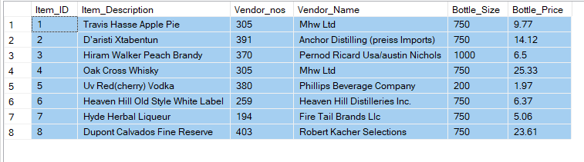

**-------------------------------------------------------------------**

INSERT INTO Products_Table VALUES

(1, 'Canada', 'Carretera', 1618.5, 3, 20, '32370', '32370', '16185', '16185', '2014-01-01', 1, 'January', 2014),

(2, 'Germany', 'Carretera', 1321, 3, 20, '26420', '26420', '13210', '13210', '2015-01-01', 1, 'January', 2015),

(3, 'France', 'Carretera', 2178, 3, 15, '32670', '32670', '21780', '10890', '2016-06-01', 6, 'June', 2016),

(4, 'Germany', 'Carretera', 888, 3, 15, '13320', '13320', '8880', '4440', '2017-06-01', 6, 'June', 2017),

(5, 'Mexico', 'Carretera', 2470, 3, 15, '37050', '37050', '24700', '12350', '2018-06-01', 6, 'June', 2018),

(6, 'Germany', 'Carretera', 1513, 3, 350, '529550', '529550', '393380', '136170', '2019-12-01', 12, 'December', 2019),

(7, 'Germany', 'Montana', 921, 5, 15, '13815', '13815', '9210', '4605', '2020-03-01', 3, 'March', 2020),

(8, 'Canada', 'Montana', 2518, 5, 12, '30216', '30216', '7554', '22662', '2021-06-01', 6, 'June', 2021);

SELECT * FROM Products_Table

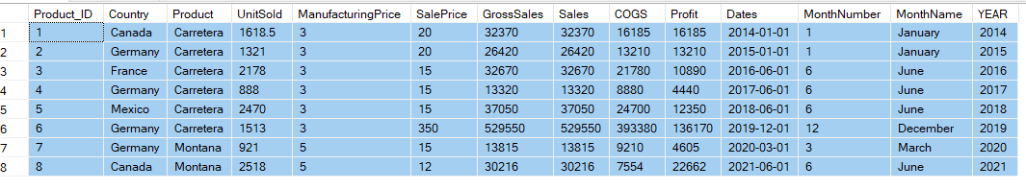

1. **Delete those product having the Units Sold 1618.5 , 888 and 2470.**

DELETE FROM Products_Table

WHERE UnitSold IN (1618.5 , 888, 2470)

SELECT * FROM Products_Table

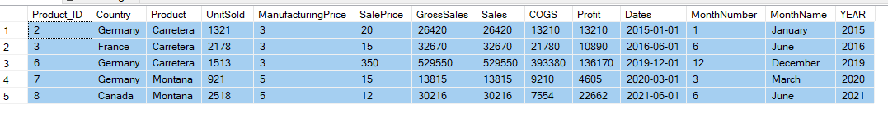

1. **Select all records from the ITEMS_TABLE table.**

USE Brands

Select * from Items_Table

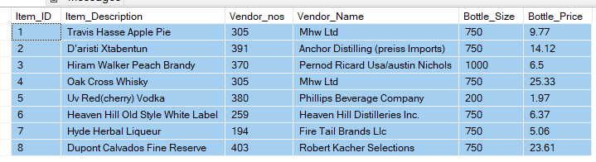

1. **Select the item_description and bottle_price for all items in the ITEMS_TABLE table.**

SELECT Item_Description, Bottle_Price FROM Items_Table

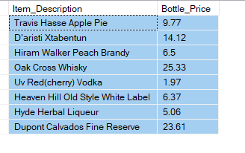

1. **Find the item_description and bottle_price of items where bottle_price is greater than 20.**

SELECT Item_Description, Bottle_Price FROM Items_Table

WHERE Bottle_Price > 20;

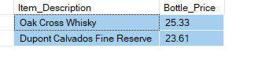

1. **Select Unique Country from the product_sales table**

USE Products

SELECT DISTINCT Country FROM Products_Table

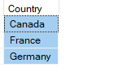

1. **Count the number of Countries in the product_sales table**

SELECT COUNTRY, COUNT(*) AS TotalCountries FROM Products_Table

GROUP BY Country

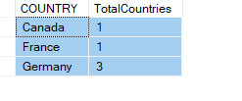

1. **How Many Countries are there which contain the sales price between 10 to 20**

SELECT COUNT(DISTINCT Country) AS TotalCountries FROM Products_Table

WHERE SalePrice BETWEEN 10 AND 20

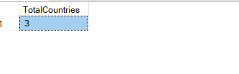

**Intermediate Questions**

1. **Find the Total Sale Price and Gross Sales**

SELECT SUM(CAST(SalePrice AS DECIMAL(10,2))) as TotalSalePrice,

SUM(CAST(REPLACE(GrossSales,',', '') as DECIMAL(10,2))) as TotalGrossSales

FROM Products_Table

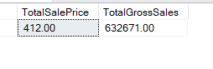

1. **In which year we have got the highest sales.**

SELECT TOP 1 YEAR, SUM(CAST(REPLACE(SALES,',','') AS DECIMAL(10,2))) AS TotalSales FROM Products_Table

GROUP BY YEAR

ORDER BY TotalSales DESC

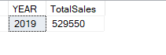

1. **Which Product having the sales of $ 37,050.00**

--Adding DELETED ROWS

INSERT INTO Products_Table VALUES

(1, 'Canada', 'Carretera', 1618.5, 3, 20, '32370', '32370', '16185', '16185', '2014-01-01', 1, 'January', 2014),

(4, 'Germany', 'Carretera', 888, 3, 15, '13320', '13320', '8880', '4440', '2017-06-01', 6, 'June', 2017),

(5, 'Mexico', 'Carretera', 2470, 3, 15, '37050', '37050', '24700', '12350', '2018-06-01', 6, 'June', 2018);

SELECT Product, SUM(CAST(REPLACE(SALES,',','') AS DECIMAL(10,2))) AS TotalSales FROM Products_Table

WHERE SALES = '37,050'

GROUP BY Product

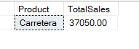

1. **Which Countries lies between profit of $ 4,605 to $ 22 , 662.00**

SELECT Country,

SUM(CAST(REPLACE(Profit, ',', '') AS DECIMAL(10,2))) AS TotalProfit

FROM Products_Table

WHERE CAST(REPLACE(Profit, ',', '') AS DECIMAL(10,2)) BETWEEN 4605 AND 22662

GROUP BY Country;

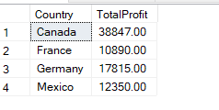

1. **Which Product Id having the sales of $ 24 , 700.00**

SELECT Product_ID FROM Products_Table

WHERE CAST(REPLACE(COGS, ',','') AS decimal(10,2)) = 24700

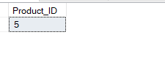

1. **Find the total Units Sold for each Country.**

SELECT Country, SUM(UNITSOLD) AS UnitSold FROM PRODUCTS_TABLE

GROUP BY COUNTRY

order by UnitSold DESC

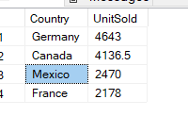

1. **Find the average sales for each country**

SELECT Country, AVG(CAST(REPLACE(Sales, ',','') AS DECIMAL(10,2))) as AverageSales FROM Products_table

GROUP BY Country

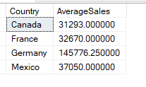

1. **Retrieve all products sold in 2014**

SELECT Product, Year FROM Products_table

WHERE YEAR = 2014

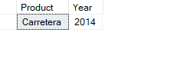

1. **Find the maximum Profit in the product_sales table.**

SELECT MAX(CAST(REPLACE(Profit, ',','') AS Decimal(10,2))) as MaxProfit FROM Products_table

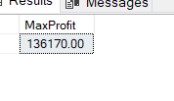

1. **Retrieve the records from product_sales where Profit is greater than the average Profit of all records.**

SELECT AVG(CAST(REPLACE(Profit, ',','') AS Decimal(10,2))) as AverageProfit

FROM Products_Table

SELECT Profit

FROM Products_Table

WHERE CAST(REPLACE(Profit, ',','') AS DECIMAL(10,2)) >

(

SELECT AVG(CAST(REPLACE(Profit, ',','') AS Decimal(10,2)))

FROM Products_Table )

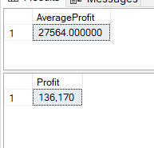

1. **Find the item_description having the bottle size of 750**

USE Brands

SELECT ITEM_ID, Item_Description FROM Items_Table

WHERE Bottle_Size = 750

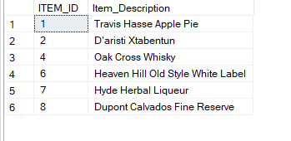

1. **Find the vendor Name having the vendor_nos 305 , 380 , 391**

SELECT ITEM_ID, Vendor_Name, Vendor_nos FROM Items_Table

WHERE Vendor_nos IN (305, 380, 391)

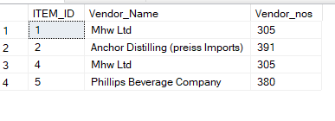

1. **What is total Bottle_price**

SELECT SUM(BOTTLE_PRICE) AS Total_Bottle_Price FROM Items_Table

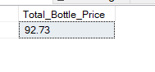

1. **Make Primary Key to Item_id**

ALTER TABLE ITEMS_TABLE

ADD CONSTRAINT PK_ITEM PRIMARY KEY(Item_id)

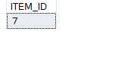



1. **Which item id having the bottle_price of $ 5.06**

SELECT ITEM_ID FROM Items_Table

WHERE Bottle_Price = 5.06



**Advance Questions**

1. **Apply INNER , FULL OUTER , LEFT JOIN types on both the table**

USE BRANDS

SELECT * FROM Items_table

USe Products

SELECT * FROM PRODUCTS_TABLE

SELECT P.*, I.* FROM Products.dbo.[Products_Table] as P

INNER JOIN

Brands.dbo.[Items_Table] as I

ON

P.Product_ID = I.Item_ID

SELECT P.*, I.* FROM Products.dbo.[Products_Table] as P

LEFT JOIN

Brands.dbo.[Items_Table] as I

ON

P.Product_ID = I.Item_ID

SELECT P.*, I.* FROM Products.dbo.[Products_Table] as P

FULL JOIN

Brands.dbo.[Items_Table] as I

ON

P.Product_ID = I.Item_ID

**INNER JOIN**

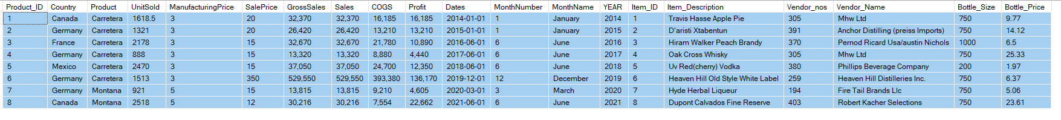

**Full Join**

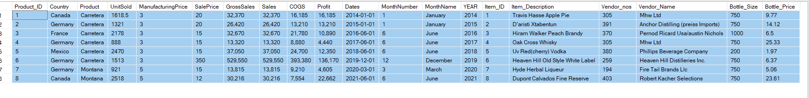

**Left Join**

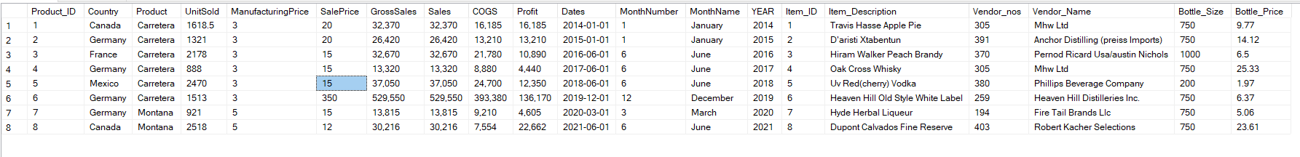

1. **Find the item_description and Product having the gross sales of 13,320.00**

SELECT P.Product, I.Item_Description, P.GrossSales FROM Products.dbo.[Products_Table] as P

INNER JOIN

Brands.dbo.[Items_Table] as I

ON

P.Product_ID = I.Item_ID

WHERE P.GrossSales = '13,320'

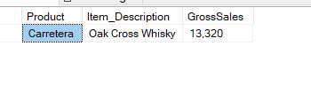

1. **Split the Item_description Column into Columns Item_desc1 and Item_desc2**

SELECT Item_Description,

SUBSTRING(Item_Description, 1, CHARINDEX(' ',Item_Description)-1) as Item_Desc1,

SUBSTRING(Item_Description, CHARINDEX(' ',Item_Description), Len(Item_Description)) as Item_Desc2

FROM Brands.dbo.Items_Table

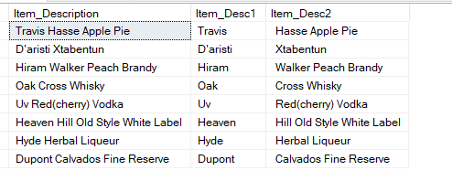

1. **Find the top 3 most expensive items in the ITEMS_TABLE table.**

SELECT TOP 3 Item_ID, BOTTLE_PRICE FROM BRANDS.DBO.ITEMS_TABLE

ORDER BY Bottle_Price DESC

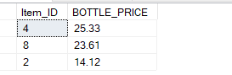

1. **Find the total Gross Sales and Profit for each Product in each Country.**

SELECT PRODUCT, Country,

SUM(CAST(REPLACE(GrossSales, ',','') AS DECIMAL(10,2))) as TotalGrossSale,

SUM(CAST(REPLACE(Profit, ',','') AS DECIMAL(10,2))) as TotalProfit

FROM PRODUCTS_TABLE

GROUP BY Product, COUNTRY

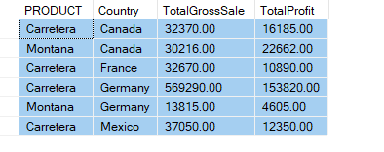

1. **Find the vendor_name and item_description of items with a bottle_size of 750 and bottle_price less than 10.**

SELECT Vendor_Name, Item_Description, Bottle_Size, Bottle_price FROM BRANDS.DBO.ITEMS_TABLE

WHERE Bottle_size = 750

AND

Bottle_Price < 10;

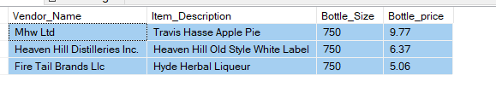

1. **Find the Product with the highest Profit in 2019.**

SELECT TOP 1 Product, CAST(REPLACE(Profit, ',','') AS Decimal(10,2)) AS TotalProfit

FROM PRODUCTS_TABLE

WHERE YEAR = 2019

ORDER BY TotalProfit DESC

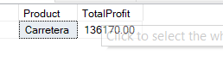

1. **Retrieve the Product_Id and Country of all records where the Profit is at least twice the COGS.**

SELECT Product_ID, Country, Profit, COGS

FROM Products_Table

WHERE CAST(REPLACE(Profit, ',','') AS Decimal(10,2)) >=

(CAST(REPLACE(COGS, ',','') AS Decimal(10,2))) * 2

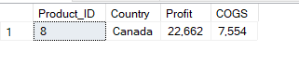

1. **Find the Country that had the highest total Gross Sales in 2018**

SELECT TOP 1 Country, CAST(REPLACE(GrossSales, ',','') AS DECIMAL(10,2)), Year

FROM products_table

WHERE YEAR = 2018

ORDER BY CAST(REPLACE(GrossSales, ',','') AS DECIMAL(10,2)) DESC

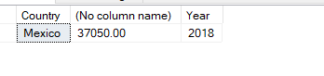

1. **Calculate the total Sales for each Month Name across all years.**

SELECT MonthName, Year, SUM(CAST(REPLACE(Sales, ',','') AS Decimal(10,2))) as TotalSales

FROM Products_Table

GROUP By MonthName, Year

Order By Year

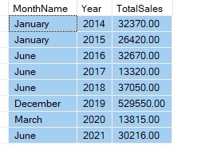

1. **List the item_description and vendor_name for items whose vendor_nos exists more than once in the ITEMS_TABLE table.**

SELECT Item_Description, Vendor_Name, Vendor_nos from Brands.dbo.Items_Table

WHERE Vendor_nos IN

(

SELECT Vendor_nos FROM Brands.dbo.Items_Table

GROUP BY Vendor_nos

HAVING COUNT(*) >1

)

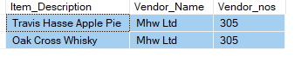

1. **Find the average Manufacturing Price for Product in each Country and only include those Country and Product combinations where the average is above 3**

SELECT Product, Country, AVG(MANUFACTURINGPRICE) AS AverageManufacturingPrice

FROM PRODUCTS_TABLE

GROUP BY Product, COUNTRY

HAVING AVG(MANUFACTURINGPRICE) > 3

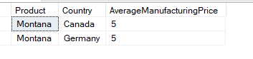

**Super-Advance Questions:-**

1. **Find the item_description and bottle_price of items that have the same vendor_name as items with Item_Id 1.**

SELECT Item_ID, Vendor_Name, Item_Description, Bottle_Price FROM BRANDS.DBO.ITEMS_TABLE

WHERE Vendor_Name = (

SELECT Vendor_Name FROM BRANDS.DBO.ITEMS_TABLE

WHERE Item_ID = 1)

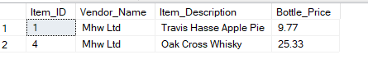

1. **Create a stored procedure to retrieve all records from the ITEMS_TABLE table where bottle_price is greater than a given value**

CREATE PROCEDURE RetrieveRecords

@BottlePrice FLOAT

AS

BEGIN

SELECT * FROM BRANDS.DBO.ITEMS_TABLE

WHERE Bottle_Price > @BottlePrice

END

EXEC RetrieveRecords @BottlePrice = 10.00

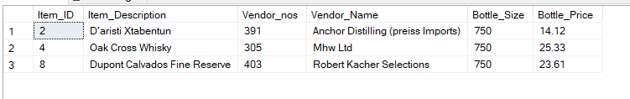

1. **Create a stored procedure to insert a new record into the product_sales table.**

CREATE PROCEDURE InsertNewRecords

@Product_ID INT,

@Country VARCHAR(50),

@Product VARCHAR(50),

@UnitSold FLOAT,

@ManufacturingPrice FLOAT,

@SalePrice FLOAT,

@GrossSales VARCHAR(20),

@Sales VARCHAR(20),

@COGS VARCHAR(20),

@Profit VARCHAR(20),

@Dates Date,

@MonthNumber INT,

@MonthName VARCHAR(25),

@YEAR INT

AS

BEGIN

INSERT INTO Products_Table

(Product_ID, Country, Product,UnitSold, ManufacturingPrice ,SalePrice,GrossSales,Sales,COGS,Profit,Dates,MonthNumber,MonthName,YEAR)

VALUES

(@Product_ID,@Country,@Product,@UnitSold,@ManufacturingPrice,@SalePrice,@GrossSales,@Sales,@COGS,@Profit,@Dates,@MonthNumber,@MonthName,@YEAR)

END;

EXEC InsertNewRecords

@Product_ID = 10,

@Country = 'India',

@Product = 'Computer',

@UnitSold = 345,

@ManufacturingPrice = 6,

@SalePrice =50,

@GrossSales = '103,500',

@Sales ='103,500',

@COGS ='51,750',

@Profit = '51,750',

@Dates = '2016-06-05',

@MonthNumber = 6,

@MonthName = 'June',

@YEAR = 2016

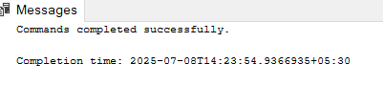

SELECT * FROM PRODUCTS.DBO.PRODUCTS_TABLE

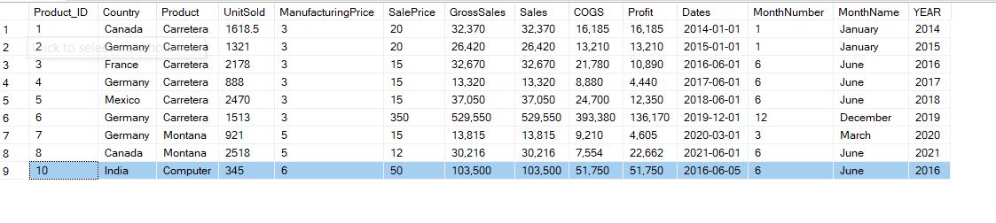

1. **Create a trigger to automatically update the Gross_Sales field in the product_sales table whenever Units_Sold or Sale_Price is updated.**
2. **Write a query to find all item_description in the ITEMS_TABLE table that contain the word "Whisky" regardless of case.**

SELECT Item_description FROM Brands.DBO.Items_Table

WHERE Item_Description LIKE '%Whisky%'

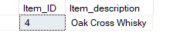

1. **Write a query to find the Country and Product where the Profit is greater than the average Profit of all products**

SELECT Country, Profit FROM PRODUCTS.DBO.PRODUCTS_TABLE

WHERE CAST(REPLACE(Profit, ',','') AS DECIMAL(10,2)) > (

SELECT AVG(CAST(REPLACE(Profit,',','') AS DECIMAL(10,2)))

FROM PRODUCTS.DBO.PRODUCTS_TABLE)

SELECT AVG(CAST(REPLACE(Profit,',','') AS DECIMAL(10,2))) AS AverageProfit

FROM PRODUCTS.DBO.PRODUCTS_TABLE

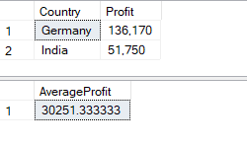

1. **Write a query to join the ITEMS_TABLE and product_sales tables on a common field (e.g., vendor_nos) and select relevant fields from both tables.**

SELECT P.Product_ID, P.Product, B.Item_Description, B.Vendor_Name, B.Bottle_Price,

P.UnitSold, P.Sales, P.Profit,P.Country, P.Dates

FROM BRANDS.DBO.ITEMS_TABLE B

INNER JOIN

PRODUCTS.DBO.PRODUCTS_TABLE P

ON

B.Item_ID = P.Product_ID

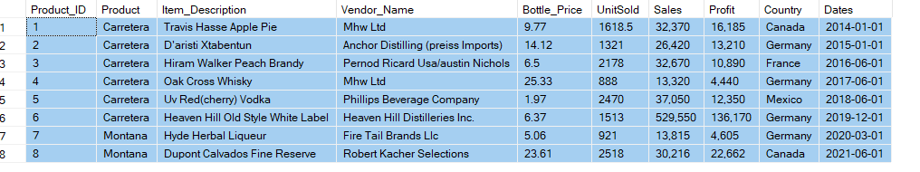

1. **Write a query to combine item_description and vendor_name into a single string for each record in the ITEMS_TABLE table, separated by a hyphen.**

SELECT *, CAST(CONCAT(Item_Description,' - ', Vendor_Name) AS VARCHAR(200)) AS ProductWithVendor

FROM BRANDS.DBO.ITEMS_TABLE

ISSUE with Size, not showing complete String

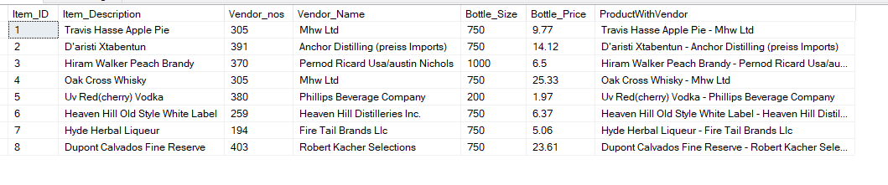

SELECT *, LEFT(CONCAT(Item_Description, ' - ', Vendor_Name), 50) AS ProductWithVendor

FROM Brands.dbo.Items_Table;

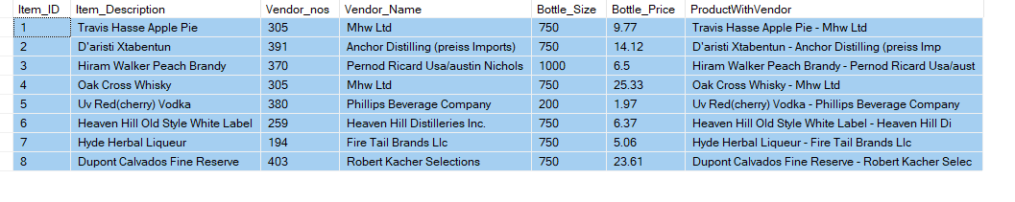

1. **Write a query to display the bottle_price rounded to one decimal place for each record in the ITEMS_TABLE table.**

SELECT *, ROUND(Bottle_Price,1) as RoundBottlePrice FROM BRANDS.DBO.ITEMS_TABLE

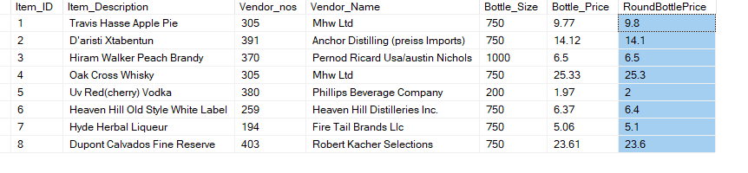

1. **Write a query to calculate the number of days between the current date and the Date field for each record in the product_sales table.**

SELECT Dates, DATEDIFF(DAY,Dates, GETDATE()) AS TotalDays FROM PRODUCTS.DBO.PRODUCTS_TABLE

